**Packet Tracer - Subnet Scenario 2**

**Addressing Table**

|  |  |  |  |  |
| --- | --- | --- | --- | --- |
| Device | Interface | IP Address | Subnet Mask | Default Gateway |
| R1 | G0/0 | 172.31.1.1 | 255.255.255.240 | N/A |
| S0/0/0 | 172.31.1.65 | 255.255.255.240 | N/A |
| R2 | G0/0 | 172.31.1.17 | 255.255.255.240 | N/A |
| S0/0/0 | 172.31.1.78 | 255.255.255.240 | N/A |
| S0/0/1 | 172.31.1.81 | 255.255.255.240 | N/A |
| R3 | G0/0 | 172.31.1.33 | 255.255.255.240 | N/A |
| S0/0/0 | 172.31.1.97 | 255.255.255.240 | N/A |
| S0/0/1 | 172.31.1.94 | 255.255.255.240 | N/A |
| R4 | G0/0 | 172.31.1.49 | 255.255.255.240 | N/A |
| S 0/0/0 | 172.31.1.110 | 255.255.255.240 | N/A |
| S1 | VLAN 1 | 172.31.1.2 | 255.255.255.240 | 172.31.1.1 |
| S2 | VLAN 1 | 172.31.1.18 | 255.255.255.240 | 172.31.1.17 |
| S3 | VLAN 1 | 172.31.1.34 | 255.255.255.240 | 172.31.1.33 |
| S4 | VLAN 1 | 172.31.1.50 | 255.255.255.240 | 172.31.1.49 |
| PC1 | NIC | 172.31.1.14 | 255.255.255.240 | 172.31.1.1 |
| PC2 | NIC | 172.31.1.30 | 255.255.255.240 | 172.31.1.17 |
| PC3 | NIC | 172.31.1.46 | 255.255.255.240 | 172.31.1.33 |
| PC4 | NIC | 172.31.1.62 | 255.255.255.240 | 172.31.1.49 |

**Objectives**

**Part 1: Design an IP Addressing Scheme**

**Part 2: Assign IP Addresses to Network Devices and Verify Connectivity**

**Scenario**

In this activity, you are given the network address of 172.31.1.0 /24 to subnet and provide the IP addressing for the network shown in the Topology. The required host addresses for each WAN and LAN link are labeled in the topology.

**Part 1:**     **Design an IP Addressing Scheme**

**Step 1:**     **Subnet the 172.31.1.0/24 network based on the maximum number of hosts required by the largest subnet.**

1. Based on the topology, how many subnets are needed?

Ans: 7 subnets are needed.

1. How many bits must be borrowed to support the number of subnets in the topology table?

Ans: Maximum number of hosts = 14 , so we have to borrow 4 bits to support the

Number of subnets.

1. How many subnets does this create?

Ans: With the 4 network bits, we can create, 2^4 = 16 subnets.

1. How many usable host addresses does this create per subnet?

Ans: No. Of usuable host address = 2^4 – 2 =16 – 2 = 14.

**Note:** If your answer is less than the 14 maximum hosts required for the R3 LAN, then you borrowed too many bits.

1. Calculate the binary value for the first five subnets. Subnet zero is already shown.

Ans:

Net 0 : 172. 31 . 1 . 0 0 0 0 0 0 0 0

Net 1 : 172. 31 . 1 . 0 0 0 1 0 0 0 0

Net 2 : 172. 31 . 1 . 0 0 1 0 0 0 0 0

Net 3 : 172. 31 . 1 . 0 0 1 1 0 0 0 0

Net 3 : 172. 31 . 1 . 0 1 0 0 0 0 0 0

f.     Calculate the binary and decimal value of the new subnet mask.

Subnet Mask Calculation:

11111111 . 11111111 . 11111111 . 11110000

255 . 255 . 255 . 240

g.    Complete the **Subnet Table**,listing all available subnets, the first and last usable host address, and the broadcast address. The first subnet is done for you. Repeat until all addresses are listed.

**Note**: You may not need to use all rows.

**Subnet Table**

|  |  |  |  |  |
| --- | --- | --- | --- | --- |
| Subnet  Number | Subnet IP | First usuable host  IP | Last usuable host  IP | Broadcast  Address |
| 0 | 172.31.1.0 | 172.31.1.1 | 172.31.1.14 | 172.31.1.15 |
| 1 | 172.31.1.16 | 172.31.1.17 | 172.31.1.30 | 172.31.1.31 |
| 2 | 172.31.1.32 | 172.31.1.33 | 172.31.1.46 | 172.31.1.47 |
| 3 | 172.31.1.48 | 172.31.1.49 | 172.31.1.62 | 172.31.1.63 |
| 4 | 172.31.1.64 | 172.31.1.65 | 172.31.1.78 | 172.31.1.79 |
| 5 | 172.31.1.80 | 172.31.1.81 | 172.31.1.94 | 172.31.1.95 |
| 6 | 172.31.1.96 | 172.31.1.97 | 172.31.1.110 | 172.31.1.111 |

**Code For The Subnetting Network:**

Code for R1:

***Configuaration for G0/0:***

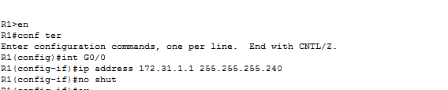

***Configuaration for S0/0/0:***

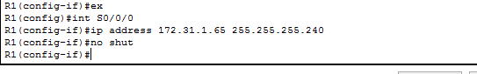

Code for R2:

***Configuaration for G0/0:***

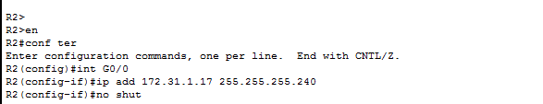

***Configuaration for S0/0/0 and S0/0/1:***

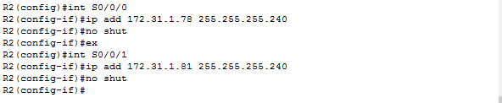

Code for S3:

***Configuaration of IP Address , including Default Gateway:***

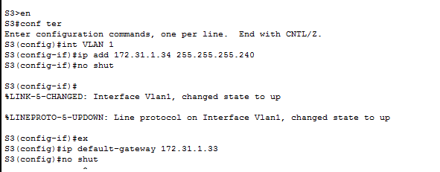

Code for PC4:

***Configuaration of IP Address , including Default Gateway:***

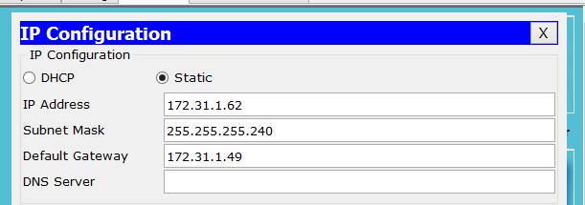

**Figure of the given Subneting Network after implimenting the Code:**

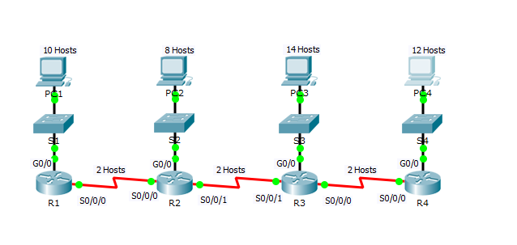

**Packet Tracer Score:**

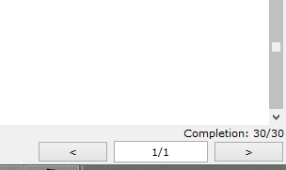

**Packet Tracer - Designing and Implementing a VLSM Addressing Scheme**

**Addressing Table**

|  |  |  |  |  |
| --- | --- | --- | --- | --- |
| **Device** | **Interface** | **IP Address** | **Subnet Mask** | **Default Gateway** |
| Building1 | G0/0 | 172.31.103.1/27 | 255.255.255.224 | N/A |
| G0/1 | 172.31.103.33/27 | 255.255.255.224 | N/A |
| S0/0/0 | 172.31.103.97/30 | 255.255.255.252 | N/A |
| Building2 | G0/0 | 172.31.103.65/28 | 255.255.255.240 | N/A |
| G0/1 | 172.31.103.81//28 | 255.255.255.240 | N/A |
| S0/0/0 | 172.31.103.98/30 | 255.255.255.252 | N/A |
| ASW-1 | VLAN 1 | 172.31.103.2/27 | 255.255.255.224 | 172.31.103.1 |
| ASW-2 | VLAN 1 | 172.31.103.34/27 | 255.255.255.224 | 172.31.103.33 |
| ASW-3 | VLAN 1 | 172.31.103.66/28 | 255.255.255.240 | 172.31.103.65 |
| ASW-4 | VLAN 1 | 172.31.103.82/28 | 255.255.255.240 | 172.31.103.81 |
| Host-A | NIC | 172.31.103.30/27 | 255.255.255.224 | 172.31.103.1 |
| Host-B | NIC | 172.31.103.62/27 | 255.255.255.224 | 172.31.103.33 |
| Host-C | NIC | 172.31.103.78/28 | 255.255.255.240 | 172.31.103.65 |
| Host-D | NIC | 172.31.103.94/28 | 255.255.255.240 | 172.31.103.81 |

**Objectives**

**Part 1: Examine the Network Requirements**

**Part 2: Design the VLSM Addressing Scheme**

**Part 3: Assign IP Addresses to Devices and Verify Connectivity**

**Background**

In this activity, you are given a /24 network address to use to design a VLSM addressing scheme. Based on a set of requirements, you will assign subnets and addressing, configure devices and verify connectivity.

**Part 1:**   **Examine the Network Requirements**

**Step 1:**     **Determine the number of subnets needed.**

You will subnet the network address 172.31.103.0/24. The network has the following requirements:

•         **ASW-1** LAN will require **27** host IP addresses

•         **ASW-2** LAN will require **25** host IP addresses

•         **ASW-3** LAN will require **14** host IP addresses

•         **ASW-4** LAN will require **8** host IP addresses

How many subnets are needed in the network topology?

Ans: 5 subnests are needed.

**Step 2:**     **Determine the subnet mask information for each subnet.**

1. Which subnet mask will accommodate the number of IP addresses required for **ASW-1**?

Ans: Reguired Subnet Mask = 255 . 255 . 255 . 224

How many usable host addresses will this subnet support?

Ans: Usuable Host addresses supports = 2^5 – 2 = 30

1. Which subnet mask will accommodate the number of IP addresses required for **ASW-2**?

Ans: Reguired Subnet Mask = 255 . 255 . 255 . 224

How many usable host addresses will this subnet support?

Ans: Usuable Host addresses supports = 2^5 – 2 = 30

1. Which subnet mask will accommodate the number of IP addresses required for **ASW-3**?

Ans: Reguired Subnet Mask = 255 . 255 . 255 . 240

How many usable host addresses will this subnet support?

Ans: Usuable Host addresses supports = 2^4 – 2 = 14

1. Which subnet mask will accommodate the number of IP addresses required for **ASW-4**?

Ans: Reguired Subnet Mask = 255 . 255 . 255 . 240

How many usable host addresses will this subnet support?

Ans: Usuable Host addresses supports = 2^4 – 2 = 14

1. Which subnet mask will accommodate the number of IP addresses required for the connection between **Building1** and **Building2**?

Ans: Reguired Subnet Mask = 255 . 255 . 255 . 252

**Part 2:**   **Design the VLSM Addressing Scheme**

**Step 1:**     **Divide the 172.31.103.0/24 network based on the number of hosts per subnet.**

a.     Use the first subnet to accommodate the largest LAN.

b.    Use the second subnet to accommodate the second largest LAN.

c.     Use the third subnet to accommodate the third largestLAN.

d.    Use the fourth subnet to accommodate the fourth largestLAN.

e.     Use the fifth subnet to accommodate the connection between **Building1**and**Building2**.

**Step 2:**     **Document the VLSM subnets.**

Complete the **Subnet Table**,listing the subnet descriptions (e.g. ASW-1 LAN), number of hosts needed, then network address for the subnet, the first usable host address, and the broadcast address. Repeat until all addresses are listed.

**Subnet Table**

|  |  |  |  |  |
| --- | --- | --- | --- | --- |
| **Subnet Description** | **Number of Hosts Needed** | **Network Address/CIDR** | **First Usable Host Address** | **Broadcast Address** |
| 1 | 27 | 172.31.103.0/27 | 172.31.103.1 | 172.31.103.31 |
| 2 | 25 | 172.31.103.32/27 | 172.31.103.33 | 172.31.103.63 |
| 3 | 14 | 172.31.103.64/28 | 172.31.103.65 | 172.31.103.79 |
| 4 | 8 | 172.31.103.80/28 | 172.31.103.81 | 172.31.103.95 |
| 5 | 2 | 172.31.103.96/30 | 172.31.103.97 | 172.31.103.99 |

**Step 3:**     **Document the addressing scheme.**

a.     Assign the first usable IP addresses to **Building1** for the two LAN links and the WAN link.

b.    Assign the first usable IP addresses to **Building2** for the two LANs links. Assign the last usable IP address for the WAN link.

c.     Assign the second usable IP addresses to the switches.

d.    Assign the last usable IP addresses to the hosts.

**Part 3:**   **Assign IP Addresses to Devices and Verify Connectivity**

Most of the IP addressing is already configured on this network. Implement the following steps to complete the addressing configuration.

**Step 1:**     **Configure IP addressing on Building1 LAN interfaces.**

**Step 2:**     **Configure IP addressing on ASW-3, including the default gateway.**

**Step 3:**     **Configure IP addressing on Host-D, including the default gateway.**

**Code For The VLSM Network:**

Code for Building 1:

***Configuaration for G0/0:***

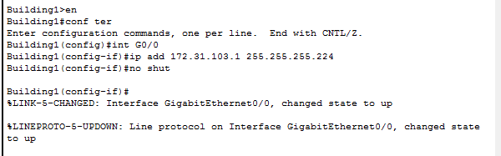

***Configuaration for G0/1:***

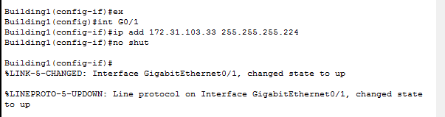

***Configuaration for S0/0/0:***

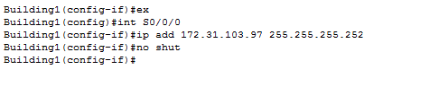

Code for ASW – 3 , including the default gateway:

***Configuaration of IP Address:***

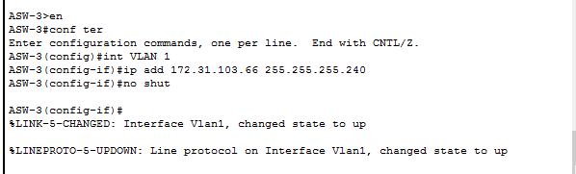

***Configuaration of Default Gateway:***

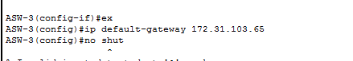

Code for Host - D , including the default gateway:

***Configuaration IP Address on Host-D including Default Gateway:***

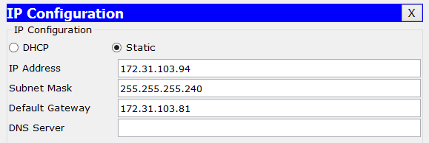

**Packet Tracer Score:**



**Figure of the given Subneting Network after implimenting the Code:**

